My Favorite Books
By – Cyndi Summers
*Both of these books are great to use to teach the concept of living and non-living.
Sylvester and the Magic Pebble - by William Steig
Activity – Give students their own rocks. Paint them or decorate them with glue and glitter. Let them name their rocks and write a story about them.
Solomon and the Rusty Nail – by William Steig
Activity – Bring in some zinc or steel nails. Put the nail in clear plastic cups of soda, salt water, tap water, and vinegar to watch them rust. Which one will rust the fastest?
*Books that inspire and create a love for words and reading
Max’s Words – by Kate Banks
Activity – Give students newspapers and magazines to create a sentence or small paragraph by cutting out words, gluing them to a large sheet of paper or a poster, and let them construct a silly sentence/story or a serious one. They can illustrate it and share it with the class.
How Do You Read to a Rabbit? – by Andrea Wayne von Konigslow

Martin’s Big Words – by Doreen Rappaport
This book features famous quotes by Dr. Martin Luther King, Jr. His sentences that were famously spoken and recorded are written in bold and have dark quotation marks around them. Some examples are: “Everyone can be great.” “Love is the key to the problems of the world.”
Activity – After reading this story, let the students come up with words or phrases which they would love to be remembered for someday. Have them write them on a large poster or make a huge display on a bulletin board. Make sure to use large letters and big quotation marks.
This will encourage character and will remind them of the use of quotation marks also.
The Incredible Book Eating Boy – by Oliver Jeffers
Discuss how books can be like food groups. Some are short and sweet like dessert. This is a funny or silly book like “The Monster at the End of this Book” or “The Three Little Pigs.”Some are serious and filling like meat or protein in a main course. This could be a non-fiction book with a lot of information such as a “Magic School Bus” book. Other books are like vegetables. They usually teach you something by putting in an imaginative story. I think of fables and fairy tales or character education books such as “Rotten Ralph.” The grains/breads type of book is a classic story such as “Corduroy” or “The Snowy Day.”
Activity – Make a book pyramid, a pantry, or a refrigerator and fill it with some of your favorite staples. Think of it as your grocery list for good healthy helpings of words.
Do Not Open This Book – by Michaela Muntean
This is just a funny book. It is very similar to “The Monster at the End of the Book” and uses reverse psychology to create a desire to read.
The Pig in the Spigot – by Richard Wilbur
The poem style or format can get you to notice little words that are found in bigger words. It would go along with teaching “word chunking.” Sometimes the little word will help you to figure out a word, but sometimes it does no good at all.
*Books about color, art, creativity and individuality
Little Blue and Yellow – by Leo Lionni
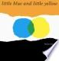
The Dot – by Peter H. Reynolds
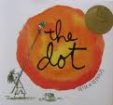
The Big Orange Splot – by Daniel Manus Pinkwater
This book has so much to offer. I read this book when we are reading “The Dot” in our basal reader. I usually read “Little Blue and Yellow” too. We study “ea” words that week in spelling also. There are many “ea” words in this book. I love the part of the story that says, “A seagull flew over Mr. Plumbean’s house. He was carrying a can of bright orange paint. (No one knows why.)” And he dropped the can (no one knows why) right over Mr. Plumbean’s house.” Have children come up with the answers. This would be an interesting writing prompt! It would also be fun to have each child design, draw, and color a funny house. Use large bulletin paper to make a street map and place the houses on it. For a character lesson, you could discuss about being yourself. I could just go on and on about this book and available ideas!
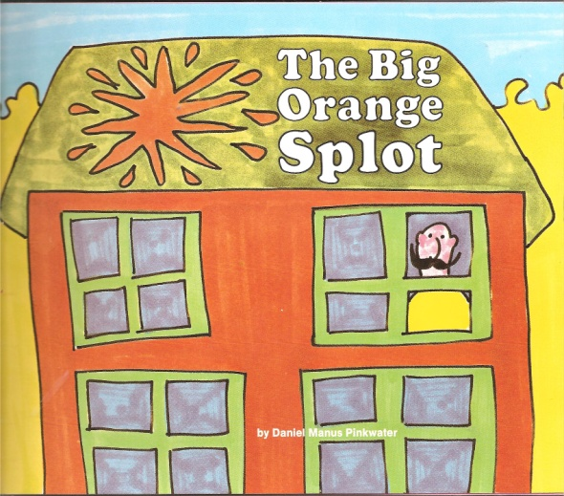
Green as a Bean – Karla Kuskin
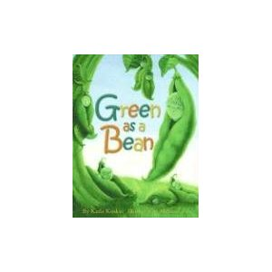
The Most Wonderful Egg in the World – by Helme Heine
*Books for Thinking & Writing
The Great Fuzz Frenzy – by Janet Stevens and Susan Stevens Crummel
This book is amazing! Kids love it! It is a story about what happens when a tennis ball accidentally rolls into a prairie dog hole.
Activity – I bring in a tennis ball. I read the first few pages and then let them brainstorm ideas of what they think will happen. When we get to the part about the fuzz, I pull off some fuzz from my tennis ball. Give the students some cotton balls or stuffing to make something out of it just as the prairie dogs do. Let them write about it.
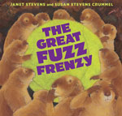

The Giant Jam Sandwich - by John Vernon Lord
“One hot summer in Itching Down, Four million wasps flew into town.” They did horrible things to the townspeople. How can they get rid of the wasps?
This is another good brainstorming book and writing prompt. Students will build connections to “Millions of Cats” and “Cloudy with a Chance of Meatballs.”
Big Chickens- by Leslie Helakoski

*Books for Character
Five Chinese Brothers - Claire Huchet Bishop
Rotten Ralph – by Jack Gantos
Greedy Greeny - by Jack Gantos
The Story of Ping - Marjorie Flack
Albert’s Bad Word - Audrey Wood
Little Oink – Amy Krouse Rosenthal and Jen Corace
Chrysanthemum – Kevin Henkes
Wemberly Worried – Kevin Henkes
Shelia Rae the Brave – Kevin Henkes
*Books for Social Studies
The Scrambled States of America – by Laurie Keller
Celebrate the 50 States! – by Loreen Leedy
Both of these books are an excellent for teaching fun facts about the U.S.A!
T is for Tennessee – by E. J. Sullivan
If You Lived 100 Years Ago – by Ann McGovern
*Books that are Fairy Tales/Tall Tales with oomph!
Starlight Goes to Town – Harry Allard
The Dog Who Cried Wolf – Keiko Kasza
PondLarker – by Fred Gwynne
Hog-Eye – Susan Meddaugh
Rude Giants – Audrey Wood
Sausages – Jessica Souhami
Waynetta and the Cornstalk – Helen Ketteman
Kate and the Beanstalk – Mary Pope Osborne
Sleeping Bobby – Will Osborne and Mary Pope Osborne
Slender Ella and Her Fairy Hogfather – Vivian Sathre

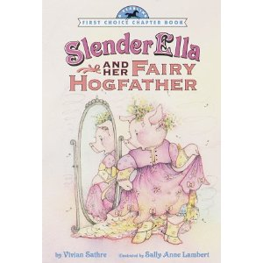
Extra! Extra! Fairy Tale News From Hidden Forest – by Alma Flor Ada
Carmine A Little More Red – by Melissa Sweet
Squids will be Squids – Joh Scieszka and Lane Smith
Swamp Angel – Paul O. Zelinsky
Jack and the Dreamsack – Laurence Anholt
Three Little Wolves and the Big Bad Pig – by Eugenios Trivizas
And the Dish Ran Away with the Spoon – Janet Stevens Crummel

